SRINIVAS UNIVERSITY
COLLEGE OF PHYSIOTHERAPY
Mangalore – 575001, Karnataka, India

Srinivas Research Centre For Stroke Rehabilitation
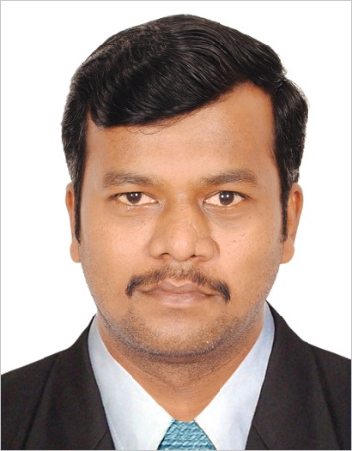

Dr.Jeyaganesh Vellaisamy (PT)
Associate professor

Rehabilitation is an essential component of universal health coverage along with promotion, prevention, treatment and palliation. There is an increasing need for rehabilitation worldwide associated with changing health and demographic trends of increasing prevalence of noncommunicable diseases and population ageing. The stroke plays a major role in producing disability among survivors due to their complicated neurological involvement in motor control. And it is a major condition which demand global level focus towards rehabilitation, promoting health and prevention too. This research centre aiming to contribute the maximum effort to support it through its research work in order to add the evidences.

Objectives
- To establish an innovative research work to promote the evidence based practice.
- To enhance the usage of advanced rehabilitation methods and techniques.
- To promote the quality of treatment through updating the knowledge with research works.
- To guide the students in the domain of stroke rehabilitation and its advancements in research and clinical practice.
- To mould the students in the area of research activities and publications.

Research activities:
- “A study to analyze the relationship between the decline of cognition and fine motor skills in elderly population” in International Journal Of Physiotherapy DOI:10.15621/ijphy/2018/v5i4/175696, 145-148.

Ongoing research works:
- Virtual reality in improving balance control among sub-acute stroke patients.
- Relationship between loading distribution in between both lower extremities in chronic stroke patients.
- Relationship between fine motor skills and the duration of rehabilitation.

